**Indexing**

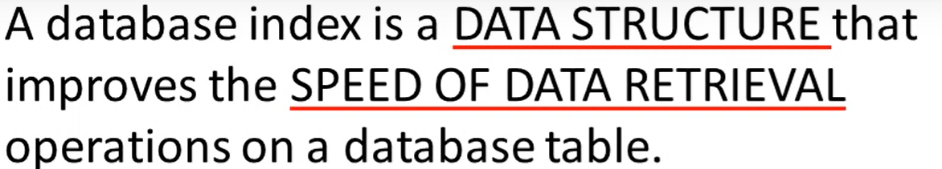

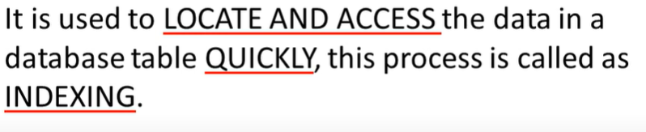

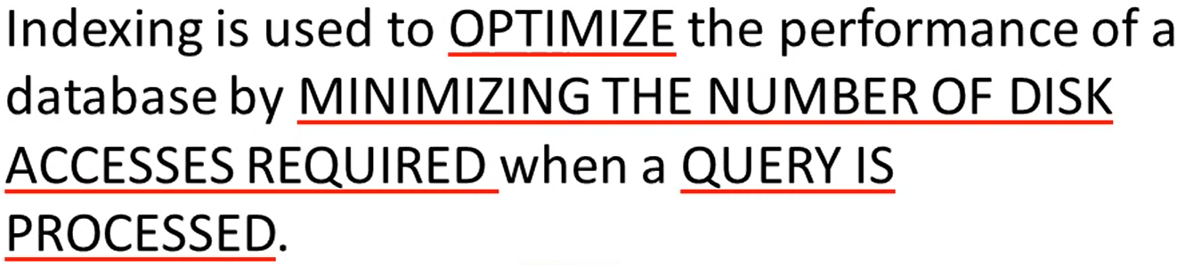

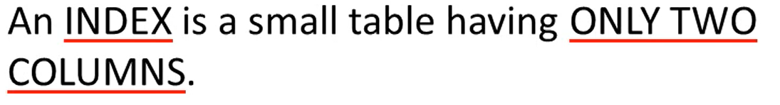

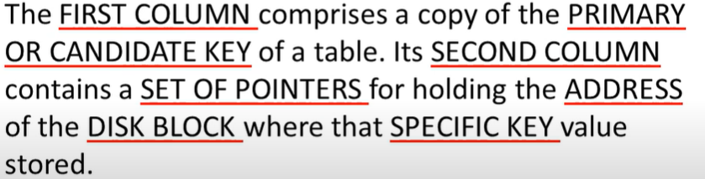

|  |  |
| --- | --- |
| Search Key | Data Reference |

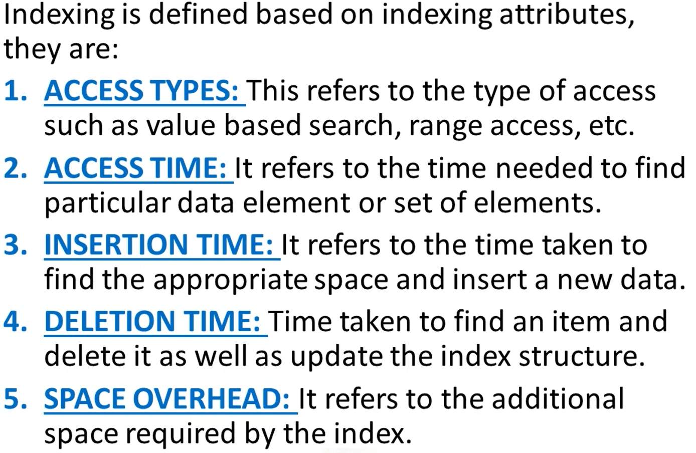

**Types of index**

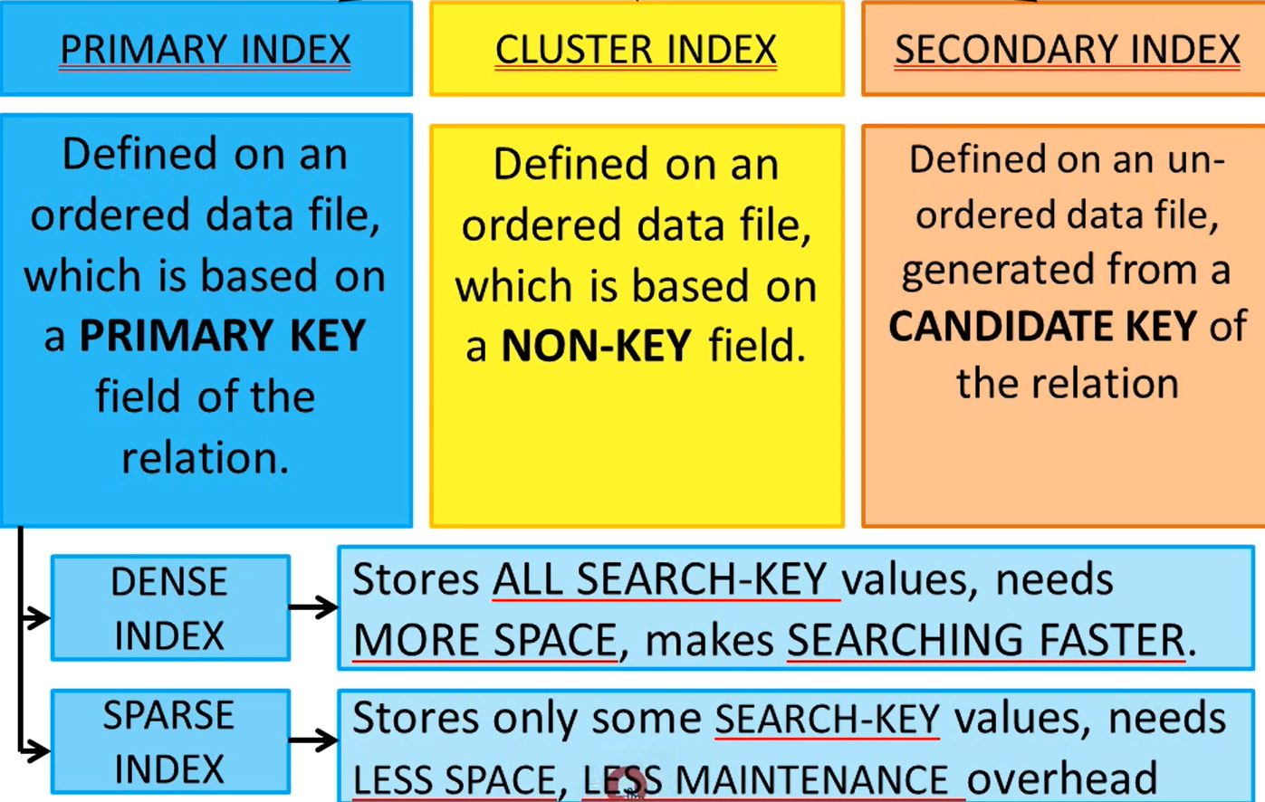

**Dense rank**

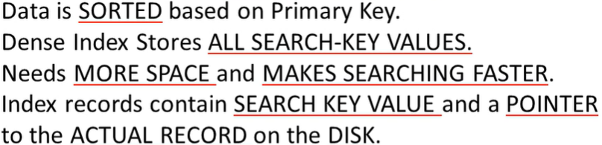

Eg:-

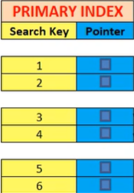 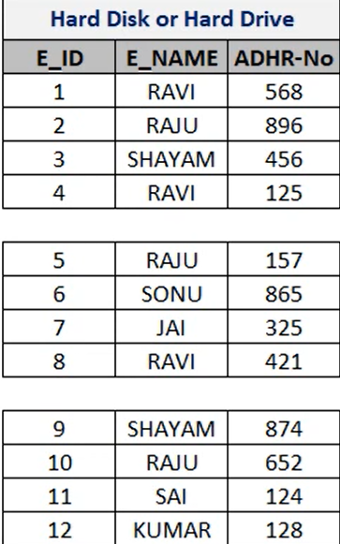

Here E_ID is primary key of the db table.

So pointer will point the search key which map to E_ID.

**Sparse Index**

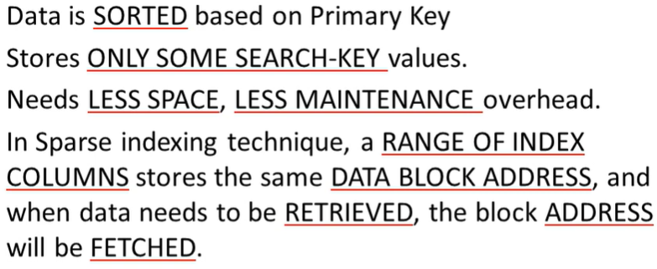

**Eg**

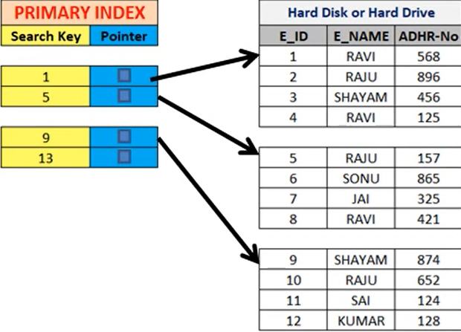

**Sparsing is based on leader of the block ie (sparse the leading anchor of the block)**

**Clustered INDEX**

**When to use:-**

**🡪ordered data**

**🡪has primary key**

**🡪non-key based search**

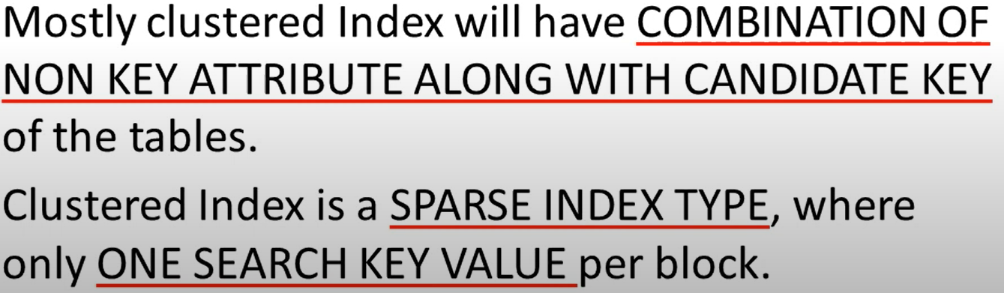

**Eg**

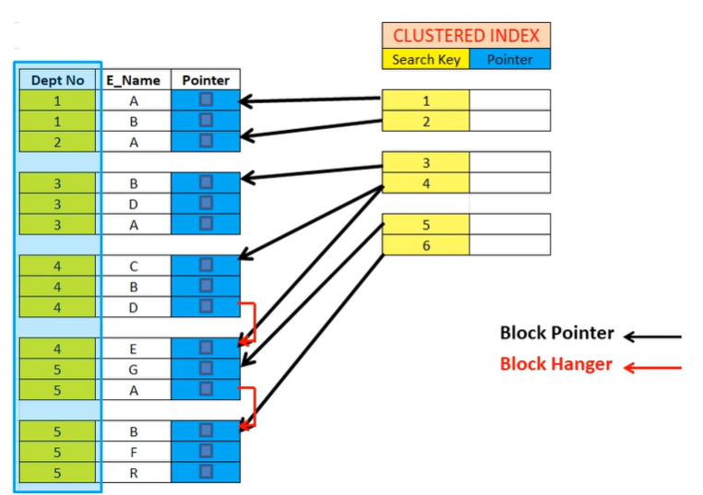

**Secondary Index**

**When to use:-**

**🡪Unordered data**

**🡪Non-key search value**

**🡪Already have a primary key**

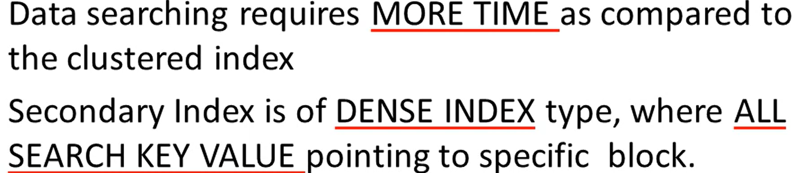

**Eg**

**Based on name which is not a primary key**

**🡪First ordering the name In secondary index**

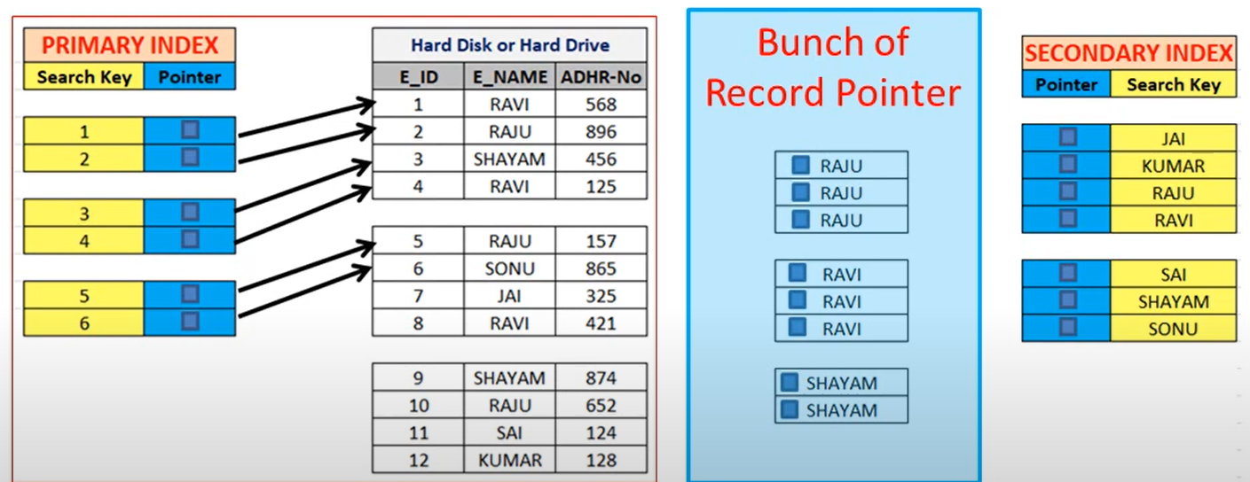

**Based on aadhar number**

**🡪First ordering the aadhar number in secondary index**

